Response to Previous Review – None
1. Introduction: Identification of the Problem & Benefits to the Stakeholders
The geographical focus for this integrated project (Integration of spatially gridded, high-resolution remote sensing data for scheduling irrigation in real-time grower tools for Puerto Rico, the Caribbean, and Florida) will be across Puerto Rico (PR), the U.S. Virgin Islands (VI), and westward into Florida (FL). The motivation is the need to develop and disseminate to land-grant extension faculties and their agriculture clientele high-resolution, gridded products that both improve upon existing grower-focused applications and develop new products that provide decision support information on irrigation scheduling. Goal: To assist agricultural producers in PR, FL and the VI to make better decisions relative to their water use, through use of new innovative irrigation scheduling tools built on remote sensing monitoring data, intelligent use of water resources, and to increase knowledge within agricultural agencies that interact with local farmers.
Pressures of competing water demands, mandates to protect natural ecosystems, and dependence of agriculture on irrigation, produce stress on water supplies. USGS (2008) reported that 1.671 million acres (82.5%) of the 2.024 million acres of non-pasture agriculture in FL were irrigated. Irrigation needs are also realized in PR where the Irrigation System, servicing the island’s three irrigation districts, does not have capacity to provide water commensurate with present-day full agricultural production. During drought, water from the PR system may be inadequate for both agricultural and domestic needs, while annually a large percentage of the water (up to 80% in the Lajas Valley) is discharged to the ocean for lack of storage capacity, resulting in soil erosion and the degradation of coral reef ecosystems. Similar problems are evident across the broader Caribbean. Thus, better water management systems and more accurate irrigation scheduling would benefit these agricultural regions. Real-time information on soil moisture (SM) and evapotranspiration (ET) and incorporation of modeling products can be used to produce tools to meet this irrigation decision making need.
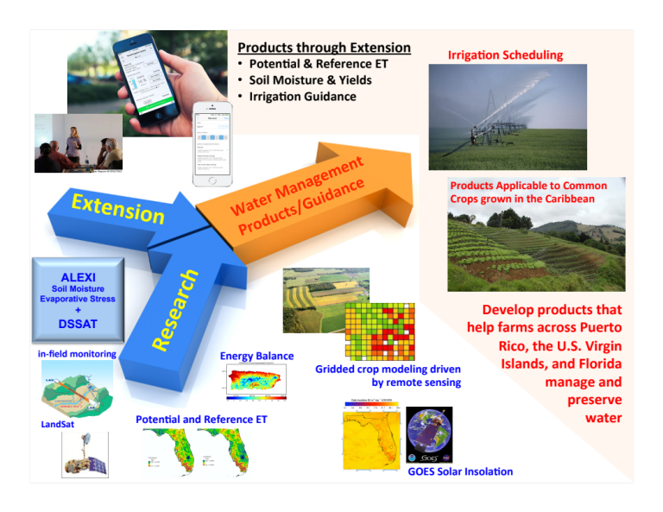
Figure 1: Schematic of proposed research and extension activities for this project. The important input datasets and products are listed in blue, and within the “Research” component of this diagram, while the output products to be applied to meet the 2014 USDA Agriculture and Food Research Initiative (AFRI) proposal Water for Agriculture Challenge Area are highlighted in the top center of the diagram.
The extension tools that will result from this project will rely heavily on remote sensing of SM, ET and rainfall, which the proposal team has well over a decade of experience developing. The tools will comprise a modeling system that more efficiently links regional SM remote sensing and crop stress to crop dynamics, and then to irrigation scheduling information, to aid farmers and agricultural managers in making better short-term irrigation management decisions. The main hypotheses are: (1) Algorithms that use remotely sensed visible and thermal data supply better proxy SM and ET (reference and actual) datasets in areas where precipitation observations are sparse or unreliable for use in irrigation scheduling. (2) Integration of remotely sensed SM proxy data into a real-time crop model will provide growers with an assessment of crop water stress, which when combined with ET and rainfall data provide more efficient irrigation scheduling, thereby benefiting farmers and other users of water resources, facilitating more efficient agricultural and water management in regions with limited water supplies, or where the demands on water are increasing.
Figure 1 shows schematically the flowchart of this project connecting data and models, with an emphasis on combining ongoing research and extension activities to form enhanced irrigation scheduling and water management tools. The main project objectives are: (1) To increase knowledge of how remote sensing datasets (solar insolation, SM, ET, rainfall) can be used to estimate parameters required for crop growth modeling, and application of such prediction methods for optimizing water applications for minimal run-off and deep percolation. (2) To use knowledge from objective #1 to design real-time tools with farmer input that provide site and crop-specific information at 1-10 km spatial resolution, including a water stress indicator and forecast data with irrigation schedules. (3) To train extension agents and market new tools to farmers and other water managers to optimize tool application, planting strategies (e.g., primed acclimation, or specifically drought stressing a crop early so that it is more resilient if a drought occurs later) and irrigation through well-established extension pathways.
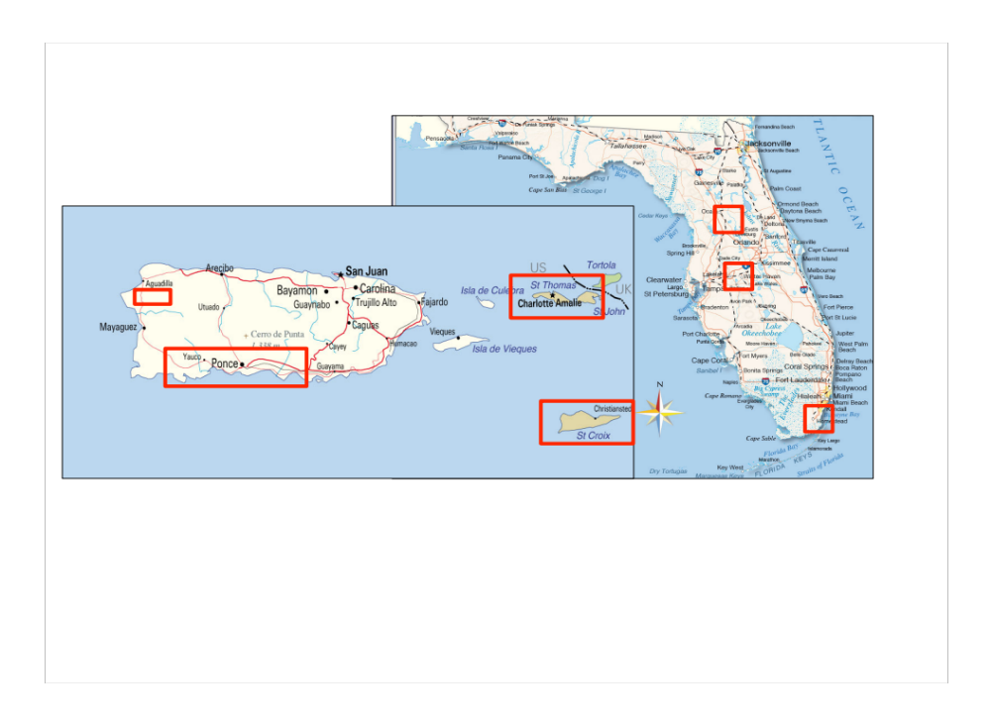
Figure 2: Project domain, from Puerto Rico, the U.S. Virgin Islands, to Florida. Over Puerto Rico, red rectangles indicate key calibration and validation domains where agricultural production is high.
The study region shown in Fig. 2 is characterized by large populations, economically important agricultural production and tourism revenues as well as protected natural areas. Water management varies depending on water supply, storage, and demands. PR and the VI currently import 85 and 95%, respectively, of their food, mostly from the U.S. Over the next 30 years, as climate variability reduces certainty to maintain such high importation percentages, PR and the VI will want to increase their food security by increasing production in the islands. This will drastically increase the demand for water and will result in competition between the different sectors of society. Water supplies are also subject to climate change and variability and natural disasters which impact water availability through altered rainfall, variable radiative water losses via ET, and water storage limitations in the system. Agriculture benefits from irrigation through increased yields, and in fact, much of agriculture would not be economically viable without irrigation. This is particularly true in FL where the majority of vegetable crops are grown during the dry season, and in southern PR and much of the VI where the climate is considered semi-arid. Table 1 shows the dollars per acre that can be lost by a farmer in PR when water is not applied at 100% of the crop water requirement. Recent studies show that improved irrigation efficiency occurs when irrigation-scheduling decisions are made based on soil water conditions, plant water stress, and/or when ET increases water use efficiency of crops (Dukes and Scholberg, 2005; Zotarelli et al. 2009; Kisekka, et al. 2010; Migliaccio et al. 2010; Kiggundu et al. 2012). However, a recent survey in the PR indicated 54% of the participants based their irrigation schedule on experience rather than using ET or SM based information.
Table 1: Dollars lost per acre for different percentages of crop water requirement applied for 12 different crops in Puerto Rico.
 | PERCENT OF CROP WATER REQUIREMENT APPLIED
 | 40 | 50 | 80 | 100 | 130 | 150 | 180
CROP* | $ LOSS / ACRE
Cowpeas | 47 | 32 | 10 | 0 | 12 | 35 | 69
Cucumber | 111 | 76 | 25 | 0 | 15 | 56 | 124
Cabbage | 256 | 174 | 57 | 0 | 21 | 103 | 247
Watermelon | 293 | 199 | 65 | 0 | 23 | 114 | 277
Plantain and Banana (Plantilla) | 318 | 216 | 71 | 0 | 24 | 122 | 299
Squash | 390 | 265 | 87 | 0 | 27 | 146 | 359
Onion | 543 | 369 | 121 | 0 | 34 | 195 | 490
Pepper | 578 | 393 | 129 | 0 | 36 | 206 | 519
Eggplant | 757 | 514 | 169 | 0 | 44 | 264 | 670
Plantain and Banana (Retoño) | 1,006 | 684 | 225 | 0 | 76 | 388 | 945
Melon, Cantaloupe y Honeydew | 1,027 | 698 | 229 | 0 | 56 | 352 | 899
Roots and Tubers | 1,041 | 707 | 232 | 0 | 57 | 356 | 911
*Based on model budget data from the Conjunto Tecnológico, UPR Agricultural Experiment Station.
One limitation of agricultural irrigators is the ability to determine an accurate irrigation schedule that results in minimal water losses while maintaining plant water needs in the soil. Figure 3 presents the flowchart for this project showing how three innovative model systems will be used in an integrated way. The Atmospheric Land Exchange Inverse (ALEXI; Anderson et al. 2007a) remote sensing surface energy balance model, and the Geostationary Operational Environmental Satellite–Puerto Rico Water and Energy Balance (GOES-WEB; Harmsen et al. 2010) model, provide spatially continuous, high resolution (1-10 km) data sources that can be translated into new real-time irrigation information for growers. In the past, many real-time tools developed for irrigation scheduling were limited by accurate rainfall data. Rainfall data are often too sparse to compensate for the large rainfall variability, while satellite precipitation products are generally poor in real-time applications and need retrospective corrections with actual ground-based observations. The ALEXI model removes this limitation by providing spatially continuous SM information directly from changes in land surface temperature, requiring no knowledge of antecedent precipitation. The ALEXI model also produces daily maps of f_{PET}, the ratio of actual to potential ET, every 5-10 km using GOES satellite thermal imagery and Moderate resolution Imaging Spectroradiometer (MODIS) land-surface products. f_{PET} is an effective proxy for SM in regions with coarse precipitation gauge networks needed to support drought indices, and is used to formulate an Evaporative Stress Index (ESI; Anderson et al. 2011, 2013) that correlates highly with routinely-used drought indices. We believe that use of a spatially continuous ESI and SM dataset will significantly improve previous irrigation scheduling tools by providing a more accurate estimate of the current soil water state.
GOES-WEB will be used to estimate these same variables (SM and ET) daily at 1 km resolution. Although conceptually similar to ALEXI, GOES-WEB very easy scales to the ‘farm scale’ providing irrigation requirements, which offers a significant advantage. Comparing the two approaches (ALEXI and GOES-WEB) also provides a validation of remotely sensed ET.
Proven approaches have linked radar-estimated rainfall to the Decision Support System for Agrotechnology Transfer (DSSAT) model, forming a spatially gridded crop growth model called GriDSSAT (McNider et al. 2010; the third main modeling system). Recently, DSSAT has been coupled to 5-10 km ALEXI SM to identify impending yield reductions, removing the need for measured rainfall and the weather component of DSSAT (which is often the most uncertain to characterize; Mishra et al. 2013). For this project, GriDSSAT will be optimized for use with ALEXI SM, ESI and GOES-WEB SM to estimate plant water stress, as well as current-day and projected yields for various crops (tropical crops, vegetables), and will help complete an integrated approach to estimating crop stress, optimize water use and maintain water quality using enhanced and new tools that improve real-time irrigation scheduling and crop management practices (e.g., fertilizer application; Lin et al. 2008, Garcia et al. 2006; Mullen et al. 2009).
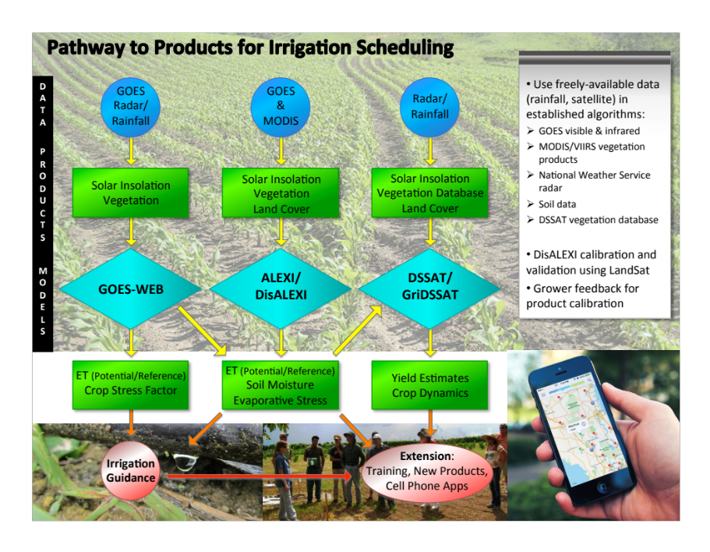
Figure 3: Project Flowchart showing the relationships between input data (top blue circles), intermediate products (upper green boxes), the main models used in this AFRI project (GOES-WEB, ALEXI/DisALEXI, DSSAT/ GriDSSAT), and the output products produced that will be used by and within the extension component of this project (lower green boxes).

The specific activities and enhancements provided by this project will be enhanced irrigation guidance, and new applications for distributing the new products, along with training via established extension pathways (lower red circles).
The project’s Land Grant Universities [University of Puerto Rico (UPR), University of Florida (UF), University of the Virgin Islands (UVI)] will capitalize on their institutional knowledge, experience and farmer connections to develop focus groups to guide development of new irrigation tools. The focus groups will be composed of agricultural producers, and used as a source of feedback for tool development. Focus group members will serve as guest speakers and provide ‘real-world’ vignettes on their experience with the irrigation tools. The established framework of the Universities will also be utilized for training and dissemination of final irrigation products. Extension specialist and agent teams will be formed to best serve clientele. Face-to-face learning events will be video recorded, as web-based learning modules reach a greater audience. All materials will be provided in English and Spanish.
Importantly, there is need to engage farmers to actively be involved in decision-making as most agricultural production comes from small-scale farms that are often family owned and operated. Average farm sizes in VI, PR and FL are 2.5, 32, and 244 acres, respectively (NASS 2014). A farmer is more inclined to adopt environmentally sound and sustainable agriculture practices if it helps their operation to remain viable and profitable. Technical training and other informal educational methodologies are needed to enhance farmers’ abilities for planning, problem solving, critical thinking and decision making for effective use of natural resources.
Collaboration between university and extension agencies will provide an information flow from research/development to farmers/producers that will benefit from real-time crop condition data by making better decisions regarding irrigation scheduling (and hence nutrient management) and harvesting. The proposed research will demonstrate the value of high-resolution remote sensing of vegetation and SM/drought related plant stress for commonly grown agricultural crops, across the Caribbean and into FL.
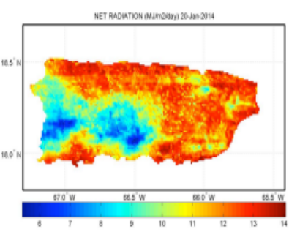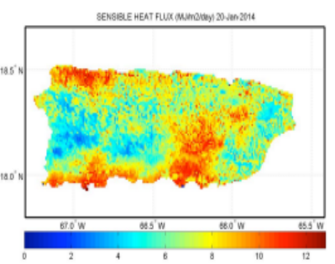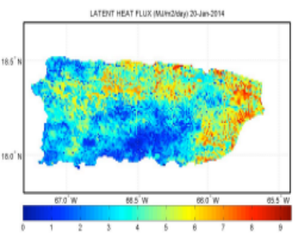
a)
b)
c)
Figure 4: Daily energy balance components produced by GOES-WEB over Puerto Rico for January 20, 2014. Shown are (a) Net Radiation, (b) Sensible Heat Flux, and (c) Latent Heat Flux, all in MegaJoules(m^{–2})(Day^{–1}).
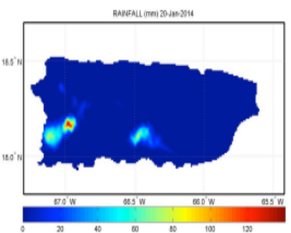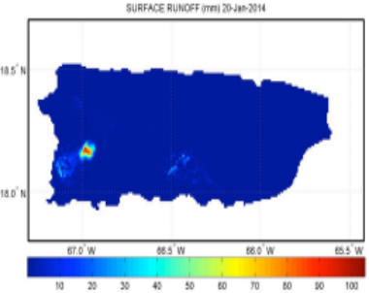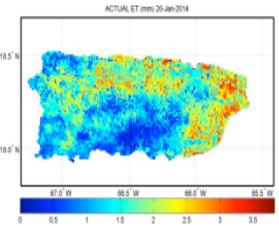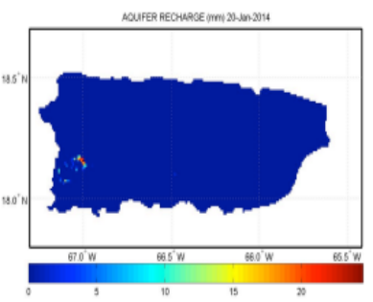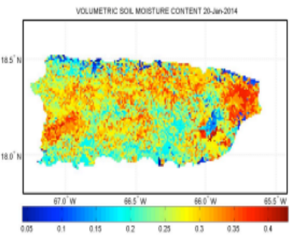
a)
b)
c)
d)
e)
Figure 5: Daily water balance components produced by GOES-WEB over Puerto Rico for January 20, 2014. Shown are (a) Rainfall (mm), (b) Surface Runoff (mm), (c) Actual ET (mm), (d) Aquifer Recharge (mm), and (e) Volumetric Soil Moisture Content.
The newly designed ALEXI-driven GriDSSAT will offer an ability to form crop specific water stress and yield estimates as a function of irrigation. From DSSAT, throughout the growing season, each grid point/pixel then will have accompanying crop-specific metrics tailored to users needs (e.g., expected yields given current moisture conditions). In Year 1, the 4 km resolution GriDSSAT system (McNider et al. 2010), as available currently in FL, will be expanded to cover PR, the VI and surrounding regions, and will be forced with GOES satellite-derived solar insolation and weather inputs from the Weather Research and Forecasting (WRF) model. The ALEXI model provides available water to the crop, and therefore it is directly applicable to a crop modeling application as one does not need to know as much information about soil texture/physics as long as you get regular ALEXI retrievals (one every few days). ALEXI SM assimilated into an advanced Land Data Assimilation System has been shown to provide optimal SM information (Hain et al. 2012), and therefore ALEXI SM information (combined with SM information from the NASA Land Information System–LIS) will be used to update SM variables across a GriDSSAT domain, yielding realistic SM evolution that is less sensitive to errors in estimated precipitation (often not available from regional radar networks), or to DSSAT ET and soil physics. In Years 1-3, research will include enhancing the crop modeling architecture and yield predictions from GriDSSAT when using SM from ALEXI. For crops where production models exist in DSSAT, such as bananas, sugar cane, vegetables (tomatoes, peppers, sweet corn) and root crops (onions, taro, tanier, cassava) GriDSSAT will be specific, as model parameters exist in the DSSAT database. GOES-WEB will subsequently provide 1 km ET and SM fields, for comparison/validation to ALEXI, and aid in the scaling to small island farms.
2. Rationale and Significance
This 2014 USDA Agriculture and Food Research Initiative (AFRI) proposal, within the Water for Agriculture Challenge Area, will address the following Program Priority Areas:
- How can the quality of water for agricultural use be sustainably improved through 2050?
- How can sufficient water supply for agricultural use be achieved in consideration of competing demands? How can production practices be adapted to be more water-use efficient, conserving, and less polluting?
- How will new knowledge be delivered to agricultural and nonagricultural water users to understand the problems or issues being addressed and actions necessary to identify appropriate solutions for these problems?
From the above discussion, the rationale for this project is the need to enhance use of innovative and robust remote sensing across a region of U.S. territories in the Caribbean and into FL where pressures on agriculture are increasing due to higher demands on limited water resources, in light of there being limited land area for agriculture amongst a growing population. Issues that accompany agriculture on small islands and high-value land (south Florida) are unique, with the largest being to simultaneously manage municipal water supplies from island runoff, while maintaining irrigation demands, and water and environmental quality as well. Given the challenges, this project will have research and extension components.
Toward addressing the FY2014 National Institute of Food and Agriculture (NIFA) initiative, this project will develop long-term solutions that will evolve to changing water management needs through use of gridded, remote sensing based datasets that rely upon national satellite programs, for defining new irrigation scheduling applicable to the Caribbean region. In the process, the project will improve agricultural management practices by forming new enhanced tools and applications for use by agricultural agents that help manage irrigation (applicable in both populated and remote regions) through the more efficient use of agricultural chemicals, consequently leading to an improvement in ground and surface water quality.
3. Approach
3.1 Models & Analysis Tools, and Proposed Enhancements
The sections below provide an overview of the main datasets, and modeling and remote sensing tools that will be used within this project. Key model enhancement tasks are also described.
a) GOES-based Solar Insolation
Daily-integrated solar radiation estimates are developed from GOES visible channel data at 1-km resolution over the study domain, and will be provided by Co-I Mecikalski. The methods of Diak and Gautier (1983), Diak et al. (1996) and Paech et al. (2009) are utilized, with validation of the solar insolation provided in Otkin et al. (2005), Mecikalski et al. (2011) and Harmsen et al. (2014). These data are used in the GOES-WEB, ALEXI and DSSAT models as described below.
b) GOES-WEB – ET Products for the Tropics
Harmsen et al. (2010) (Project PI) developed the GOES-WEB algorithm, using a methodology similar to Yunhao et al. (2001) to calculate the energy balance and to estimate actual ET in PR. In addition to GOES solar insolation, rainfall data for GOES-WEB are obtained from NOAA’s Doppler Radar (NEXRAD), while surface runoff is estimated using the Natural Resource Conservation Service (NRCS) Curve Number (CN) method (Fangmeier et al. 2005). Deep percolation or aquifer recharge is assumed to be any water that exceeds the soil field capacity. On those days in which aquifer recharge occurs the final SM is assumed to be equal to the field capacity. If the SM does not exceed the field capacity then no recharge occurs. The model is operational in the sense that it is automated and provides a suite of 25 hydro-climate variables each day, including solar radiation, ET and f_{pet}, which are available to the public via a web site (http://pragwater.com). GOES-WEB calculates the surface energy budget with each of the components expressed in their expanded forms, resulting in the effective surface temperature (T_{s}) being the only unknown variable. T_{s} is obtained by an implicit approach similar to that described by Lascano and van Bavel (2007), using the recursive root function fzero in MatLab. Given T_{s}, latent heat flux can be resolved and converted to actual ET with multiplication by the latent heat of vaporization. In GOES-WEB, reference ET is estimated using the Penman-Monteith, Hargreaves, and Priestly-Taylor methods. The program currently includes crop coefficient data for 15 vegetable crops. Figures 4 and 5 show examples of the energy and water balance components, respectively, for January 20, 2014. Image data for all hydro-climate variables are available on a public website (http://pragwater.com/goes-puerto-rico-water-and-energy-balance-goes-web-algorithm/). Archived images are available from January 2009–Present.
Another data record that will be drawn into this study is regional potential ET (at 2 km resolution) as developed over FL, involving collaboration with the U.S. Geological Survey (USGS). As outlined in Mecikalski et al. (2011), GOES solar insolation data are used within a Penman-Monteith procedure (Shoemaker et al. 2011) to generate reference ET and potential ET over a wide range of plant communities and land covers including agricultural fields (various crop types), lakes, estuary, shallow and deep water-table pasture, hay field, pine forest, wetland forest, cypress, wet prairie, marsh, citrus, sawgrass, palmetto/scrub, and urban land use. These potential ET and 1-km resolution GOES solar insolation datasets are available from 1995–Present (http://fl.water.usgs.gov/et/), and are in concert with those produced by GOES-WEB, and will provide an additional ET validation dataset for irrigation tool developments in FL.
c) Gridded Rainfall
As a means of improving the existing ET estimation tools (for irrigation management) in PR, the VI and FL, several existing gridded rainfall products will be evaluated, as a replacement to only station rain gauge data. These rainfall products are:
- Advanced Hydrologic Prediction Service precipitation (http://water.weather.gov/precip/). This product is already used in GOES-WEB, and hence its application would expand to FL. This is a multi-sensor product (radar and rain gauges), based on observed data as a byproduct of National Weather Service (NWS) operations at the 12 Continental U.S. River Forecast Centers, and is displayed as a gridded field with a resolution of ~4 x 4 km.
- NCEP 4 km Precipitation Set, Gage and Radar (http://rda.ucar.edu/datasets/ds507.5/) real-time, hourly, multi-sensor National Precipitation Analysis (NPA).
- Real-time NWS radar (TJUA radar San Juan, 18.1156° N –66.0781° E) rainfall estimates for the VI (not multi-sensor), which is not covered by the other rainfall products.
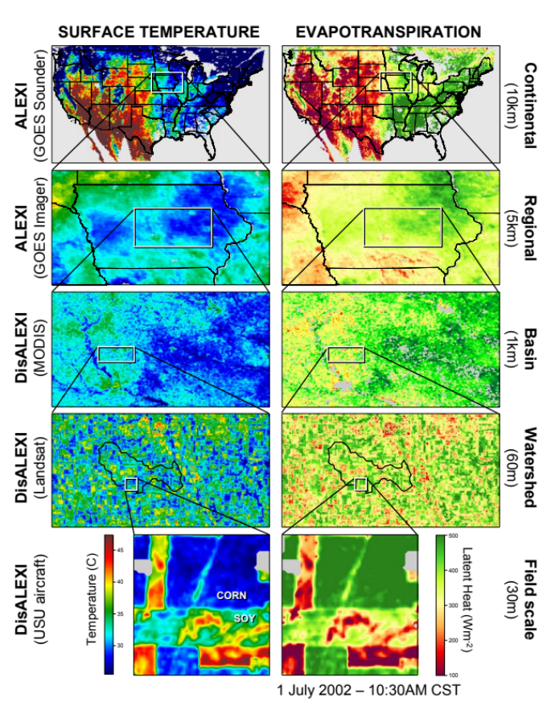
Figure 6 (Left): Multi-scale ET maps for 1 July 2002 produced with ALEXI/DisALEXI using surface temperature data from aircraft (30-m resolution), Landsat (60-m), MODIS (1-km), GOES Imager (5-km) and GOES Sounder (10-km), zooming into the Walnut Creek Watershed near Ames, Iowa, site of the SMEX02 Soil Moisture Experiment. The cont-inental-scale ET map is a 14-day composite of clear-sky model estimates. Application of the DisALEXI model is shown on the bottom left (Anderson et al. 2007c).
(Below): A schematic of the coupled land-atmosphere boundary layer (ABL) modeling scheme used in ALEXI. See text for description.
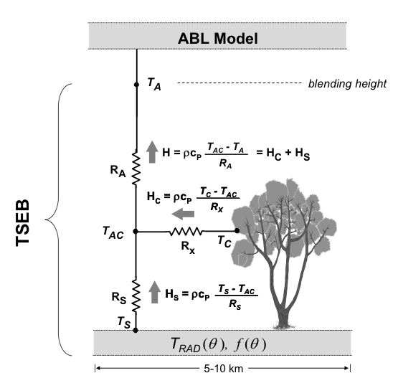
d) ALEXI and DisALEXI
In addition to GOES-WEB, we will also employ the multi-scale ALEXI/DisALEXI surface energy balance modeling system to generate maps of ET and f_{PET}: the ratio of actual ET to PET at spatial resolutions of 30 m to 4 km. ALEXI currently operates at 4-10 km horizontal resolution over the study region, driven by land-surface fields [e.g. land surface temperature (LST), leaf area index (LAI), solar insolation]. Observations from GOES, MODIS and the Visible Infrared Imaging Radiometer Suite (VIIRS) instruments provide key surface/vegetation input fields, with meteorological inputs from the WRF model. Maps of ALEXI-generated f_{PET} are formulated into an ESI (http://hrsl.arsusda.gov/drought) that represents the degree that a crop may be stressed by drought, and hence is strongly related to SM. The ESI has proven to be a valuable tool for monitoring drought in data-poor regions as it does not require antecedent precipitation data as input, yet functions as well as standard precipitation-based drought indices (Anderson et al. 2007a,b, 2011, Co-I Anderson on this project team; Anderson et al. 2012), and the ESI is being integrated into the ESI within the weekly U.S. Drought Monitor to improve response to rapid onset drought events (Otkin et al. 2014). Hain et al. (2010, 2011; Co-I Hain on this project team) demonstrated that ALEXI f_{PET} (hence, ESI) provides valuable high-resolution information regarding root zone SM conditions, with f_{PET} values of 0 (no ET) to 1 (maximum ET) translating into SM values lying between permanent wilting and field capacity.
ALEXI is a diagnostic land-surface model designed explicitly to exploit surface temperature data retrieved at 5-15 min intervals from thermal imagery using geostationary satellites. The land-surface representation in both ALEXI and DisALEXI is based on the series version of the two-source energy balance (TSEB) model of Norman et al. (1995; see also Kustas et al. 1999, 2000), and is constrained primarily by remote sensing estimates of land-surface temperature (LST). LST is a valuable metric for constraining ET estimates because varying SM conditions yield a distinctive thermal signature: moisture deficiencies in the root zone lead to vegetation stress and elevated canopy temperatures, while depletion of water from the soil surface layer causes the soil component of the scene to heat up rapidly. The TSEB partitions the composite surface radiometric temperature, T_{RAD}, into characteristic soil and canopy temperatures, T_{S} and T_{C}, based on the local vegetation cover fraction apparent at the thermal sensor view angle, f(θ): T_{RAD}(θ) ≈ f(θ)T_{C} + [1 – f(θ)]T_{S}, with f(θ) obtained from standard LAI products from MODIS (Anderson et al. 2007a). With information about T_{RAD}, LAI, and radiative forcing, the TSEB evaluates the soil (subscript ‘s’) and canopy (‘c’) energy budgets separately, computing system and component fluxes of net radiation (RN=RN_{C}+RN_{S}), sensible and latent heat (H=H_{C}+H_{S} and λE=λE_{C}+λE_{S}), and soil heat flux (G). The TSEB has a built-in mechanism for detecting thermal signatures of vegetation stress. A modified Priestley-Taylor relationship (PT; Priestley and Taylor 1972), applied to the divergence of RN within the canopy (RN_{C}), provides an initial estimate of canopy transpiration (λE_{C}), while the soil evaporation rate (λE_{S}) is computed as a residual to the system energy budget. If the vegetation is stressed and transpiring at less than the potential rate, the PT equation will overestimate λE_{C} and the residual λE_{S} will become negative. With mid-day condensation onto the soil unlikely on clear days, λE_{S} < 0 is considered a signature of system stress caused by dryness. Under such circumstances, the PT coefficient is throttled back until λE_{S} ~ 0 (expected under dry conditions). Both λE_{C} and λE_{S} are then some fraction of the canopy and soil PET rates. This approach provides surface (related to λE_{S}) and root zone (related to λE_{C}) moisture pool assessments, and thus concomitant tracking of meteorological and agricultural/ hydrologic droughts (Anderson et al. 2007a,b; Otkin et al. 2014).
In the regional ALEXI model, the TSEB is run in time-differential mode using hourly measurements of LST available from geostationary platforms. This significantly reduces model sensitivity to errors in absolute temperature retrieval (Anderson et al. 1997), but constrains ALEXI to resolutions associated with geostationary imagery (5-10 km). For higher resolution ET assessments, an ALEXI flux disaggregation algorithm (DisALEXI; Norman et al. 2003) can be applied. DisALEXI uses higher resolution TIR imagery available from polar orbiting systems such as MODIS, VIIRS or Landsat to downscale the ALEXI-based flux estimates (4-10 km) to resolutions of 30-1000 m (Anderson et al. 2004, 2007c). Typical root-mean-square-deviations in comparison with tower flux measurements (30-min averages) of H and λE are 35-40 Wm⁻² (15% of the mean observed flux) over a range in vegetation cover types and climatic conditions. Together, ALEXI/DisALEXI plus MODIS/VIIRS/Landsat data facilitate scalable flux and SM/ESI mapping using TIR imagery, zooming in from the national scale to sites of specific interest (Fig. 6), as will be valuable during the validation component of this project.
Toward increasing the spatial and temporal coverage of remote sensing-based SM estimates, ALEXI ESI signals have been combined with standard passive microwave SM retrievals (Jackson 1983; Njoku et al. 1999; 2003; Owe et al. 2008) and used to update SM states in a hydrologic land-surface model producing time-continuous SM information at both high temporal and spatial resolution (4 km, daily). The assimilation uses an Ensemble Kalman Filter system implemented within the NASA LIS (Kumar et al. 2006). The time-continuous gridded SM data stream from LIS provides an “optimal” SM analysis (Hain et al. 2011, 2012) has already been coupled to DSSAT (Mishra et al. 2013), which typically has used observed rainfall and a very simple SM scheme to monitor the yield potential for various crops. Our team has extensive experience in building land data assimilation applications and have developed similar systems over the CONUS towards the improvement of SM estimates in land surface and crop models (Hain et al. 2011, 2012; Mishra et al. 2013).
With respect to the solar insolation, used by GOES-WEB and ALEXI algorithms, the new GOES-R (and perhaps GOES-S) datasets will become available within this project’s timeframe, by 2016. Hence, one research component will involve developing and tailoring these algorithms for using 500 m resolution visible and 2 km resolution infrared data from these new systems. The project’s goals can be met with current GOES data, yet we expect significant improvements to (especially in cases of small convective clouds) with the higher resolution observations.
e) DSSAT and GriDSSAT
The DSSAT v4.5 (Jones et al. 2003; Hoogenboom et al. 2010) biophysical modeling framework includes a suite of more than 28 different cropping and fallow system models. DSSAT simulates crop growth and yields in response to management, climate, and soil conditions, and requires a minimum set of inputs such as weather, soil type and profile variables, cultivar specific parameters and field management strategies including planting dates, irrigation and fertilization. For over 25 years, this widely used crop model has been applied to predict crop yield and water use, to develop management strategies, and to study nitrogen cycling dynamics under many different soil and climate scenarios (Jones et al. 2003; Yang et al. 2006; Soler et al. 2007; Thornton at al. 2009; Liu et al. 2011; Soler et al. 2011). The model can be run for a single year or multi-year climate mode (Thornton and Hoogenboom 1994; Garcia y Garcia et al. 2006). The temporal data required by DSSAT are daily minimum and maximum temperatures, daily insolation data, and daily precipitation data, and has been applied, tested and evaluated in numerous farm scale (Lin et al. 2008; Garcia et al. 2006) and regional scale studies (Lal et al. 1993; Mullen et al. 2009).
The DSSAT system has been configured to run in a gridded mode (GriDSSAT) at ~5 km horizontal grid spacing (McNider et al. 2011). It may use three agriculturally dominant soils per county with a variety of appropriate crop/cultivar choices. The planting date is based on both latitude (early planting in the southern area) and localized temperature/SM conditions. Real-time meteorological data are provided under script control to GriDSSAT by a land surface modeling system at the NASA Marshall Space Flight Center’s (MSFC) Short-term Prediction Research and Transition (SPoRT) Center. Solar forcing is a major factor that drives photosynthesis in the crop and also controls ET, and yet is not a regular NWS observable. The University of Alabama in Huntsville (UAH) and MSFC have developed an operational system that uses the physical retrieval method (Gautier et al. 1980; Diak and Gautier 1983) with GOES satellite visible imagery to recover insolation at 4 km resolution (McNider et al. 1995). The GOES-derived insolation data (section 3.1a) have been shown to be superior to methods generating solar insolation from standard meteorological observations (McNider et al. 2011). Precipitation is one of the most important parameters in DSSAT, and gridded radar and gauge-corrected data from the NOAA NCEP Stage IV product (Lin and Mitchell 2005) provide hourly precipitation estimates to the real-time GriDSSAT model. We intend to collaborate with the Southeast River Forecast Center on refinement and evaluation of this precipitation product.
The final crop model yield results are also mapped to actual field data available from the USDA CropScape (http://nassgeodata.gmu.edu/CropScape/) so that state or regional yields can be estimated. An example of one of the many outputs is the DSSAT crop water stress index, selected as the base metric for a drought indicator. It attempts to quantify lack of water on the plant physiological process as a ratio of potential uptake to potential transpiration (Ritchie et al. 1998). In McNider et al. (2011), comparisons between regional-scale production and National Agricultural Statistical Service (NASS) yields over long climate runs showed good agreement with temporal (inter-annual) behavior of de-trended statewide NASS yields. The crop water stress index (analogous to ALEXI ESI) can be a more direct and valid measure of agricultural harm due to drought than other general indirect measures of drought such as the Palmer Drought Index or the current U.S. Drought Monitor (McNider et al. 2011). Thus, it may be a very useful metric for agricultural drought severity and for disaster declarations. As such its statistics and change are important. The crop model has been evaluated in several settings from seed trial experiments to Statewide NASS data (McNider et al. 2011).
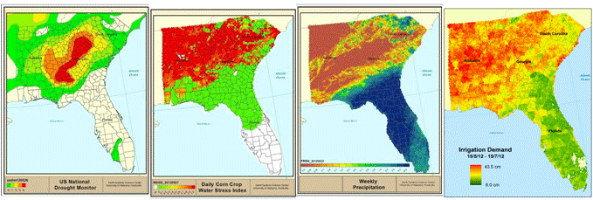
Figure 7: For the week of the 26th June 2012 (left to right): U.S. Drought Monitor, Corn water stress from GriDSSAT, Radar derived precipitation and Irrigation demand from GriDSSAT (May 15 through July 15). Note the crop stress in the GriDSSAT model that was not reflected in the Drought Monitor.
The real-time GriDSSAT can also be used to delineate short-term crop stress (on the order of days) that is not captured in the longer timescale U.S. Drought Monitor (weekly-monthly). Figure 7 provides an example of the GriDSSAT water stress that characterizes the agricultural drought compared to the U.S. Drought Monitor. It also shows the irrigation demand computed from GriDSSAT for the growing season that will be provided as a weekly update.
Current GriDSSAT projects have focused on corn crop water stress and yield. However, DSSAT/GriDSSAT provides a range of output parameters that will prove useful to growers and stakeholders for this project, such as crop growth development and responses to inputs (fertilizer, irrigation). Within this project, the point-based DSSAT tool will be calibrated over select locations in PR, VI and FL (Table 2) toward forming a high-quality, scalable agricultural management and information tool that will use input SM fields from GOES-WEB and ALEXI.
e) A Coupled ALEXI-DSSAT Model, Validation and Scaling to Yields
The DSSAT (or GriDSSAT) model is subject to various errors and uncertainties. In many areas rainfall data are sparse, inconsistently available or not of sufficient temporal resolution to drive biophysical models (Wood et al. 2000). In addition, the model contains a simple storage based soil moisture routing routine with parameters that do not relate directly to standard soil characteristics and moisture is routed in the vertical direction only (Mishra et al. 2013). For these and other reasons, the model can be difficult to calibrate to observed yields and moisture conditions (Liu et al. 2011; Thorp et al. 2011). Thus, there is the likelihood that model performance will be improved through the introduction of remotely sensed SM states.
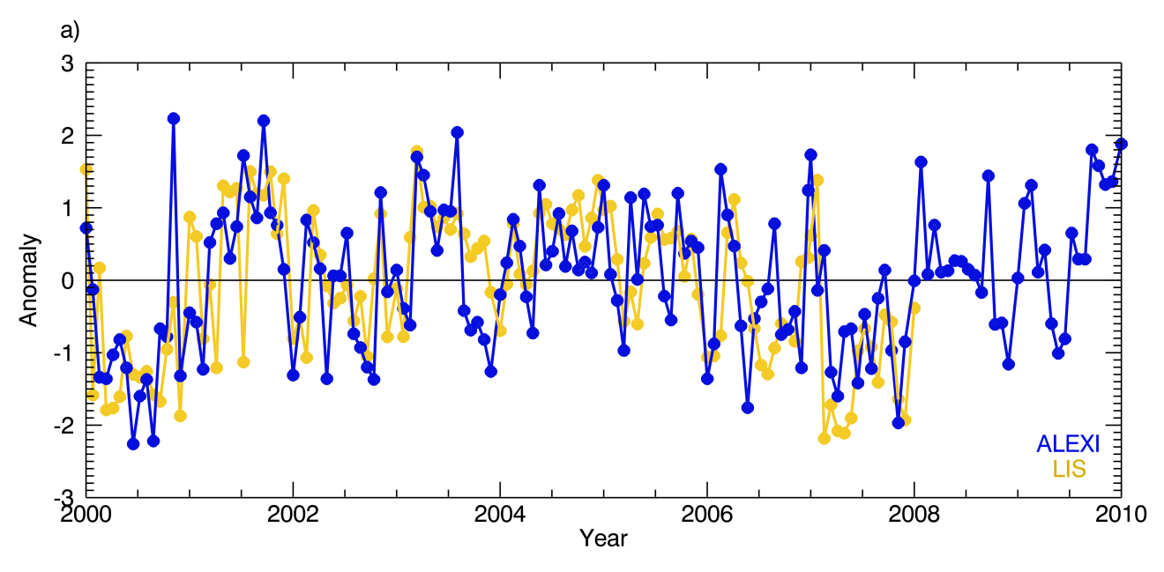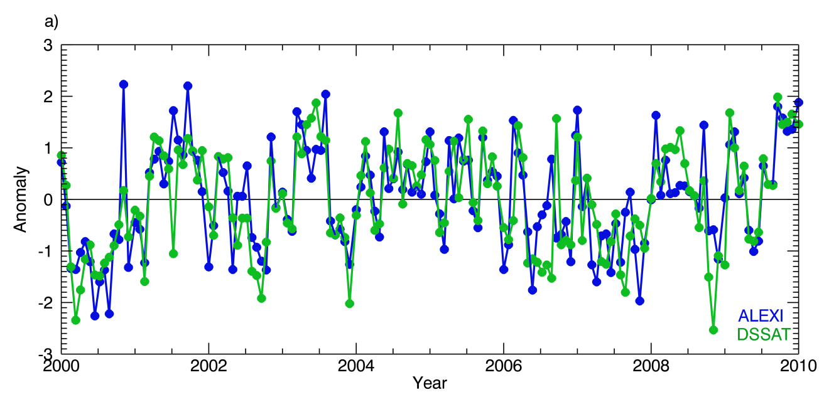
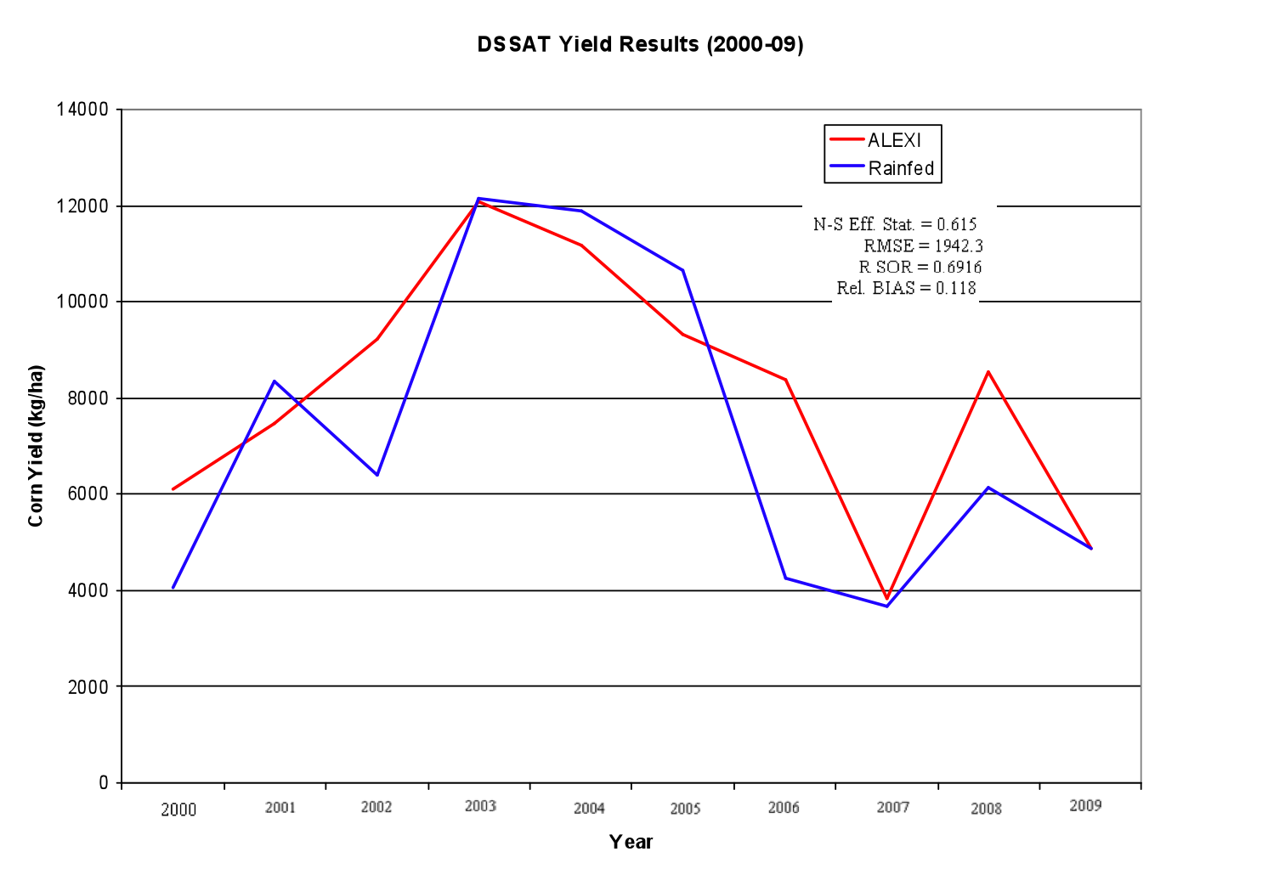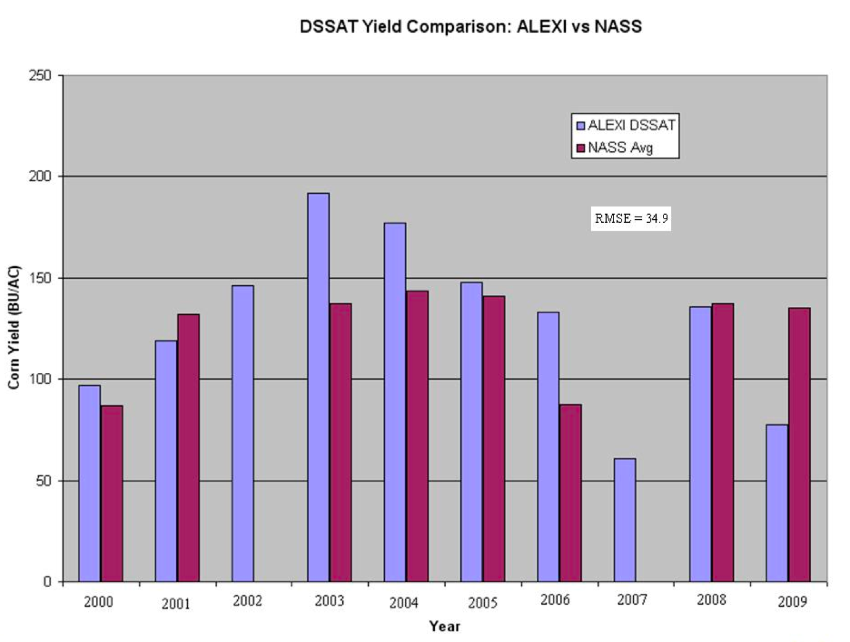
Figure 8: (Upper Left) Anomaly time series between NASA Land Information System (yellow) and ALEXI (blue), and (Upper Right) Anomaly time series between DSSAT (green) and ALEXI (blue) for the 14-day SM composite at Belle Mina, Alabama for 2000-2010. Correlation between LIS and ALEXI SM is 0.577, while correlation between DSSAT and ALEXI SM is 0.740. (Lower Left) Time series plot comparing corn yields predicted by the DSSAT model simulation with rain-fed (blue) and ALEXI forced (red) 2000-2009. (Lower Right) Comparisons of DSSAT and NASS crop yields under ALEXI SM forcing (no NASS data for 2002 and 2007).
The recent work by Mishra et al. (2013) demonstrates that ALEXI and LIS SM estimates can effectively drive the DSSAT model in estimating gridded regional yield maps, as evaluated in comparison with NASS crop yield data. In this prototype experiment, the DSSAT SM profile was simply replaced by an optimal profile derived from ALEXI on days when ALEXI observations were available. Despite only having SM updates every ~9 days from ALEXI (as it requires clear-sky conditions to retrieve SM), DSSAT was in very good agreement with NASS-observed yields. Figure 8 shows time series SM anomaly comparisons between: (a) ALEXI and LIS, (b) ALEXI and DSSAT, as well as (c) ALEXI-driven versus rain fed-driven DSSAT model simulations, and (d) DSSAT yield comparisons (ALEXI-driven versus NASS-reported). This demonstration in Fig. 8 shows the capability we bring to the USDA AFRI, namely an ability to drive DSSAT without need for rainfall estimates (e.g., from radar or satellite) and point-based soil data, while being able to obtain yield statistics very close to observed values.
The goal in Years 1-2 will be to develop the ALEXI methodology over the Caribbean, thus providing gridded ESI and SM to PR and the VI. In Mishra et al. (2013) DSSAT was run in the intervals between ALEXI observations (up to 9 days) with no precipitation input. In areas where rainfall data are available, this is not considered advisable since any available precipitation will add some value to the model. Instead, it is proposed to compute the optimal SM profile from the ALEXI data when available, and then to use this profile to update the profile in DSSAT when otherwise driven by the gridded precipitation product. ALEXI provides either the total root zone SM available or the surface SM depending on the fraction of vegetation coverage. A statistically unbiased vertical SM profile can then be determined from these data through the application of an information entropy technique described by Al-Hamdan and Cruise (2010), Singh (2010) and Mishra et al. (2013). The DSSAT profile can then be nudged towards the optimal profile through data assimilation techniques as described previously (e.g., Ensemble Kalman filters).
3.2 Proposed Research & Extension Development Activities
a) Cross Calibration/Validation of ET and SM
Calibration/validation (cal/val) activities will be a focus over the lifetime of the project for surface energy and moisture fluxes, and SM in PR, VI and FL, specific to datasets produced by ALEXI and GOES-WEB. Cal/val for fluxes will be performed using a large aperture scintillometer (LAS) technique, which measures area-averaged surface fluxes of H at scales of 0.2 to 8 km. The LAS system consists of two components: the scintillometer and a weather station (for air temperature and humidity, wind speed, RN, soil temperature and SM). The latter three parameters are required for estimating G, a required variable in the surface energy balance. The project PI has experience measuring surface energy and moisture fluxes in PR and FL using a ground-based surface energy and moisture flux/Bowen ratio instrument, and eddy covariance system (Harmsen et al. 2009). Investigators Harmsen and Mecikalski will receive hands-on training on the LAS system provided by Kipp and Zonen, the manufactures of the LAS. For this cal/val effort, we will use the LAS system over transects of differing length (e.g., 0.5 km to 5 km), which correspond to the satellite products being used. Several SM collection stations will be installed at the same locations where the scintillometer measurements are made. In PR, VI and FL we will perform cal/val studies at the locations indicated in Table 2. Florida cal/val sites will be at the UF Institute for Food and Agricultural Studies (IFAS) Research and Education Centers (RECs) in agricultural production fields. RECs also house Florida Automated Weather Network (FAWN) stations, which will provide additional data for the project (when comparing gridded rainfall products to point rainfall measurements). Data will be evaluated to identify biases and statistical properties (e.g., error characteristics). The main crops to be evaluated include tomatoes, bananas, peppers, onions, sugar cane, tomatoes, peppers, sweet corn, taro, tanier and cassava in PR and the VI. Tomatoes, peppers, potato, green beans, sugar cane, cassava and pasture will be evaluated in FL depending on available crops at UF RECs.
b) Validation of Crop Yields
A multi-tiered cal/val approach will be executed to ensure that the coupled ALEXI-DSSAT system will provide quality crop dynamics, yield estimates and drought detections over the growing season. Several methods will be employed toward quantifying the following: (1) The physical accuracy of the ALEXI-DSSAT system when operated on 10 m field- to ~1 km farm-scales when ALEXI SM drives DSSAT. (2) How do yield predictions compare across scales (i.e. in comparison to county NASS yields)? While adhering to water and energy balance constraints within DSSAT, the focus will be on comparing farm field/point simulations of crop yield from DSSAT, using observed rainfall, remotely-sensed SM and yield data, for monthly to annual time periods. The goal is to maximize agreement of ALEXI-DSSAT simulated crop yields with yields observed across testbed sites (i.e. a range of soil, rainfall and historical crop conditions).
Other objective metrics used to gauge output yield forecast quality will include determining correlation of integrated growing season ALEXI SM and DSSAT yields with USDA-NASS county-wide yield data over FL for several crop types. As absolute yields under the planned DSSAT runs may not be robust because of different crop management practices on actual farms (irrigated versus rainfed), we will compare DSSAT yields normalized/de-trended by the potential yield for the DSSAT/GriDSSAT crop being simulated, to account for systemic cultivar- or fertilizer-related increases in yields, isolating the effects of drought (soil water holding characteristics) in forecasted yields. ET estimates from ALEXI and LIS SM, GOES-WEB and the USGS-based model will be evaluated in comparison with surface flux observations collected at testbed sites. Because ALEXI pixel sizes (4-10 km) are much coarser than the surface flux footprint sampled by ground instrumentation (typically ~100 m), the aforementioned DisALEXI disaggregation algorithm (Anderson et al. 2004) will be applied using MODIS (1 km), VIIRS (750 m) and Landsat (30 m). The validated point-based DSSAT driven with ALEXI SM will be extended to cover the testbed regions by several 10 km-resolution grid cells, and finally to wider regions. Extending the domain will serve two purposes: (1) the likelihood of clear-sky retrievals from ALEXI will be increased, that then become part of the LIS SM field; (2) local variability in terms of SM and vegetation (crop types, phenology-based stress) will be represented.
Table 2: Locations of Cal/Val studies in PR, VI and FL.
Region | Conditions | Location
PR | Irrigation | Guanica
PR | Rainfed irrigation | Guanica
PR | Irrigation | Santa Isabel
PR | Rainfed irrigation | Santa Isabel
PR | Irrigation | Coloso
PR | Rainfed irrigation | Coloso
VI | Irrigation | St. Croix, West End
VI | Rainfed irrigation | St. Croix, West End
VI | Irrigation | St. Croix Mid-Isle
VI | Rainfed irrigation | St. Croix Mid-Isle
VI | Irrigation | St. Thomas
VI | Rainfed irrigation | St. Thomas
Florida | Irrigation | Homestead
Florida | Rainfed irrigation | Homestead
Florida | Irrigation | Citra
Florida | Rainfed irrigation | Citra
Florida | Irrigation | Lake Alfred
Florida | Rainfed irrigation | Lake Alfred

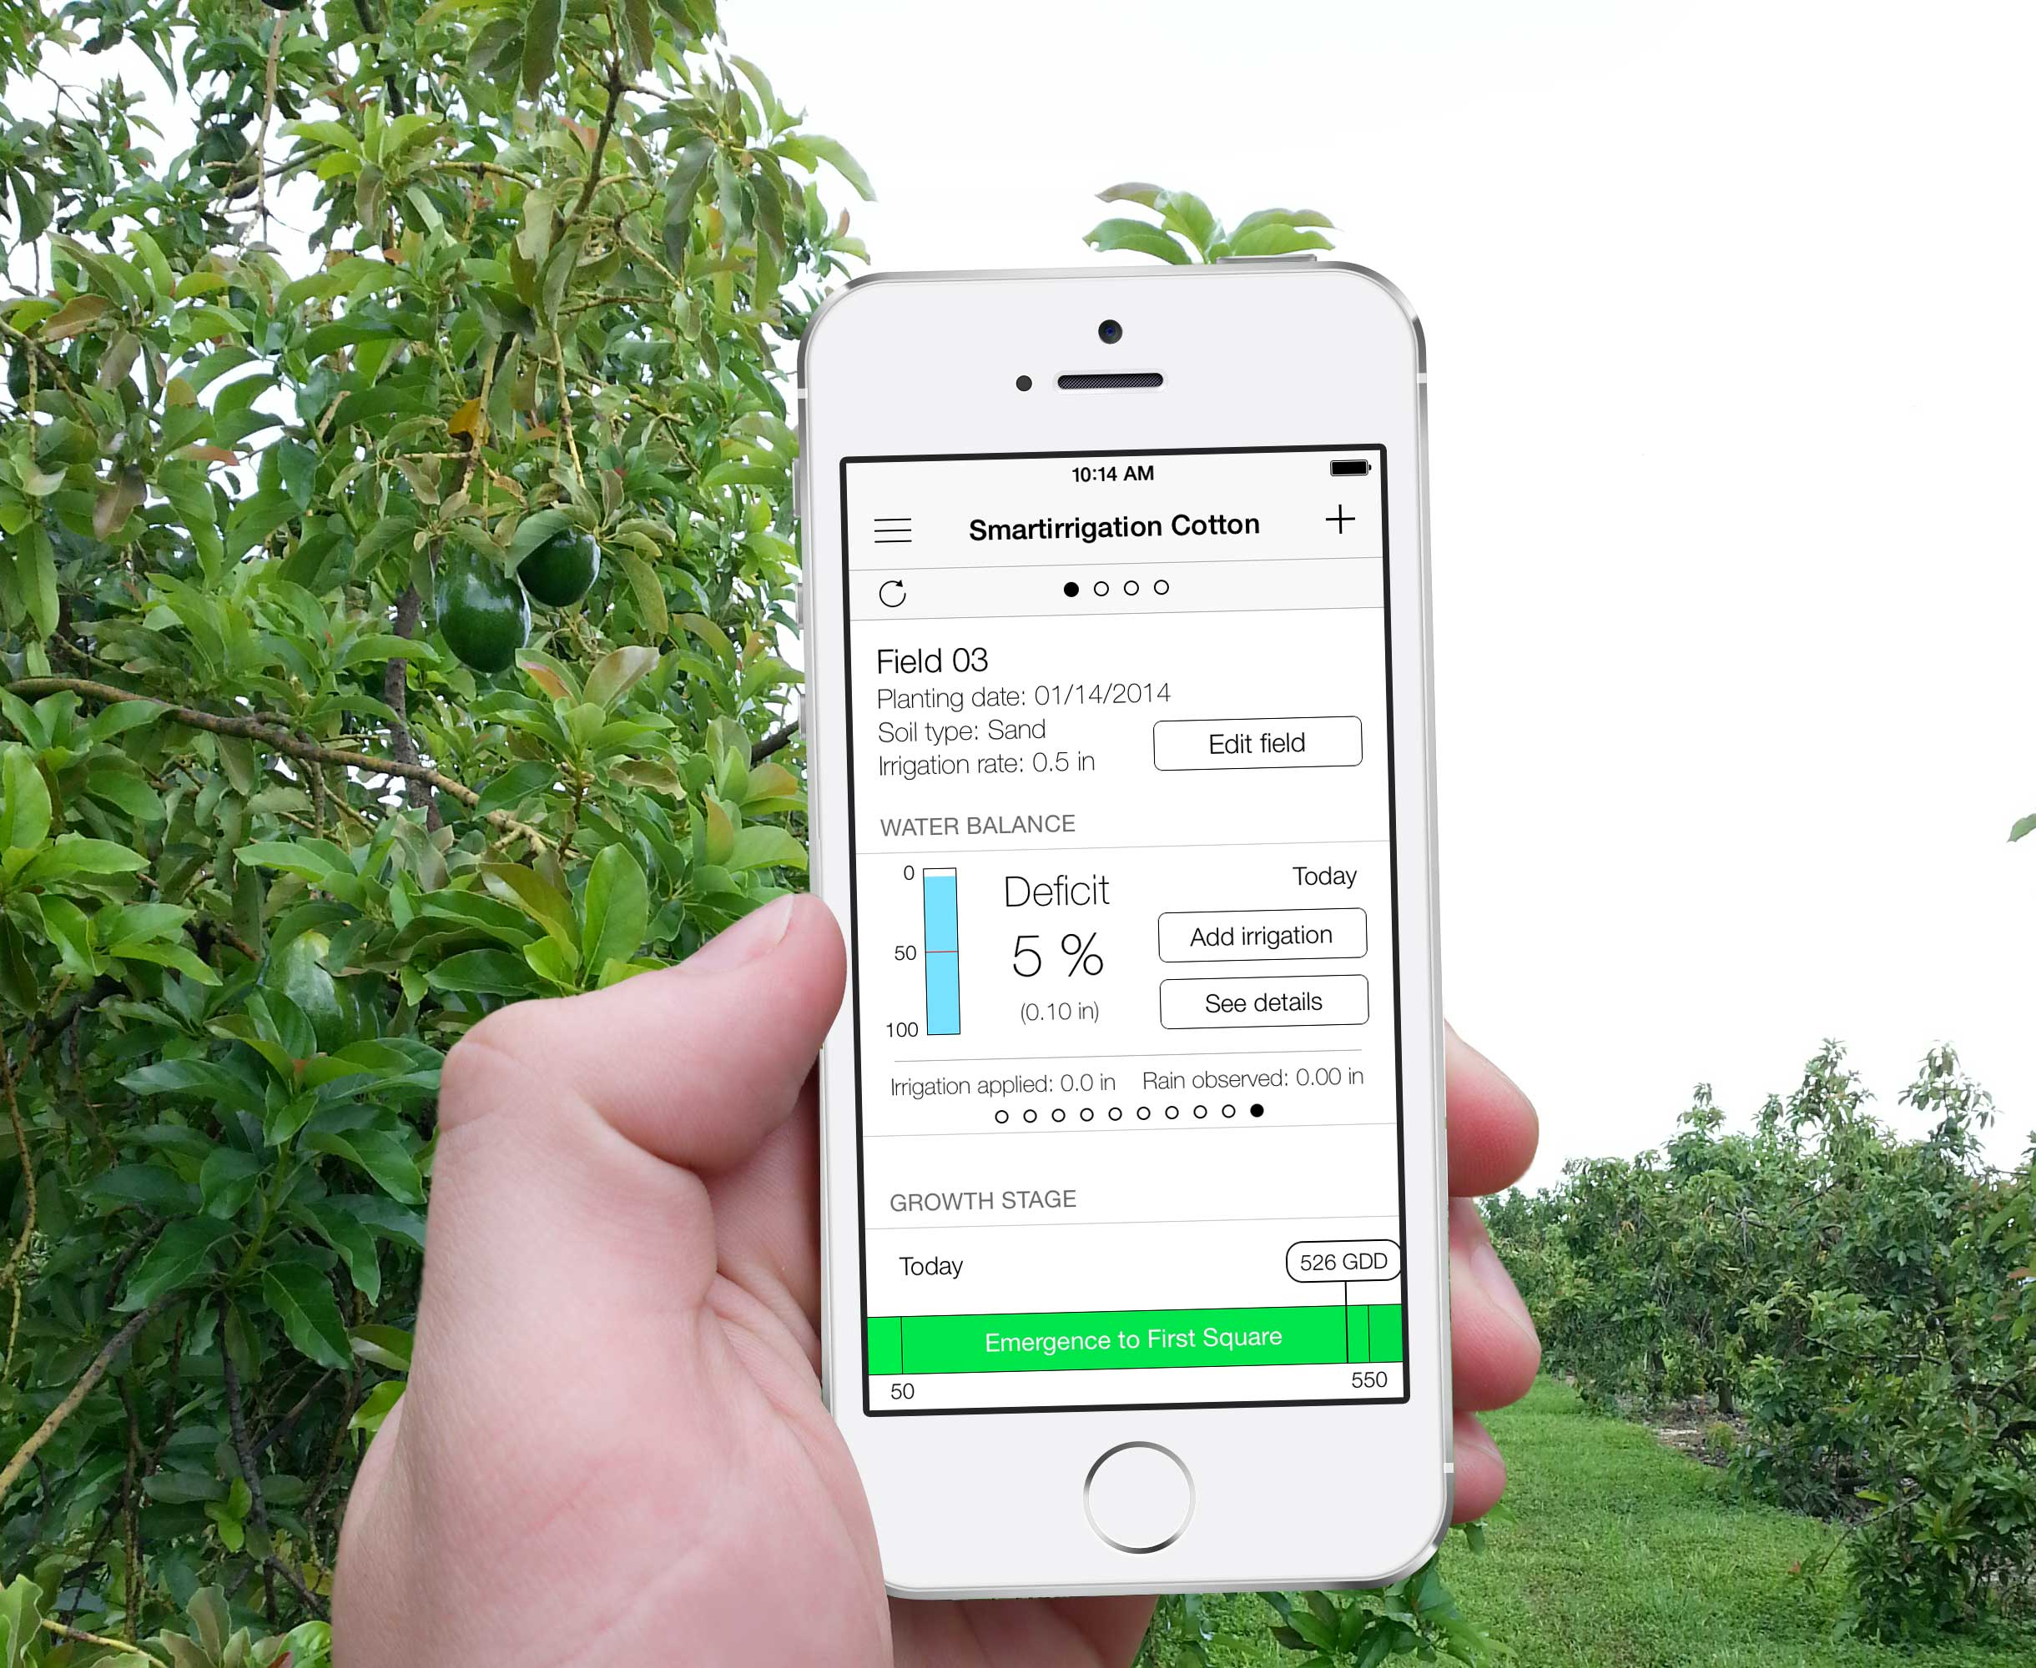
Figure 9: Example irrigation application. In this case, the “smartirrigation cotton” application, to be updated for avocados, with added SM and crop stress/ESI information from ALEXI and GriDSSAT, such that growers can have added information so to make more intelligent irrigation decisions, and how to optimize fertilizer applications.
There has already been a great deal of calibration and verification of the DSSAT algorithms for the various crop types, under a variety of soils, climate and management practices (e.g., Jagtop et al. 1993; Manuela et al. 2007; Persson et al. 2009) so that any further calibration along those lines are considered unnecessary. Instead, this project will concentrate on verification of the SM routing and ET algorithms in the model and relationships with the remotely sensed data. One of the most important questions to be answered for the field scale DSSAT runs is the optimal frequency at which to update the model with remotely sensed data. Mishra et al (2013) found that when simulating corn growth in Alabama, an update frequency of 9-12 days resulted in yields that were superior to the rain fed (non-irrigated) model when compared to county yield data. Using available yield data as well as remotely sensed and field sampled SM, the actual moisture/nutrient uptake dynamics of the model can be studied more thoroughly than before and compared with the remotely sensed data at a variety of update frequencies.
c) Irrigation Management Tools and Applications
During the 5-year project, products from the research component (e.g., output from DSSAT, ALEXI, gridded ET fields within GOES-WEB distribution system, regional rainfall) will be used to provide information to farmers that will increase their ability to irrigate land in a manner that maximizes irrigation efficiency, and maintain water quality by optimizing irrigation (e.g., avoiding nutrient leaching in sandy soils; Ellenburg 2010). Data from GOES-WEB and ALEXI will be translated into real-time, site-specific crop ET and SM data. DSSAT will use this information, as well as site and crop characteristics to estimate crop water stress. Smartphone or web based tools will be developed as the interface between the farmer and ET, SM, DSSAT information, and irrigation estimates. The new tools will be designed with farmer input so that they provide information in a format that farmers can easily translate into irrigation scheduling practices. The tools will also be customizable by the farmer so that relevant information will be included. Notification will be sent to the farmer regarding changes in irrigation management.
In PR, PI Harmsen (2012) developed a simple web-based method for scheduling irrigation based on GOES-WEB data (Harmsen et al. 2009). In the methodology the user creates a crop coefficient curve based on the FAO approach (Allen et al. 1998) and the crop water requirement is estimated from the well-known relation ET_{c} = K_{c} ET_{o}, where ET_{c} is the crop water requirement, K_{c} is the crop coefficient, which varies with crop stage, and ET_{o} is the reference ET. The user is provided links to daily NWS radar rainfall images and ET_{o} images (1-km spatial resolution for PR), and sum up rainfall and ET_{o} data for the series of days since the last irrigation was applied to determine the irrigation requirement. The methodology has recently been automated in a prototype web application called PRAGMA, which allows the user to create an account with a record of the user’s irrigation history. The application can be implemented on a desktop computer or smart phone.
Similar tools have been developed for farmers in FL and Georgia (Co-PI Migliaccio on the app development team). These smartirrigation specialty apps (smartirrigationapps.org; Fig. 9) provide irrigation schedules for specific crops. One limitation to these apps is the spatial variability of rainfall and the use of a limited number of weather stations to estimate crop irrigation schedules. Leveraging these early developments, this project provides opportunity to add to the suite of apps a new app that would provide a better estimate for rainfall. The new tool would build on previous app development knowledge of using large databases in which a user can gain site-specific information (weather/WRF model fields, SM, ET; gridded rainfall versus FAWN) from the database for use in smartirrigation apps. The goal would then be to integrate farmer feedback into the app design, forming an app that is based on the best aspects of the tools developed previously in PR and FL.
d) Extension Training
Focus teams will be established for PR, VI and VI. Each team will consist of 5-8 people and be used for introducing the new concepts of using SM and ET satellite derived data for irrigation scheduling and exploring tool development options. Specialized extension personnel will meet with the focus team and conduct discussions on tool development and potential applications. Carmen Gonzales Toro (UPR) will lead efforts in PR with extension agent counterparts. Co-I Crossman (UVI) will lead efforts in VI with his extension agent counterparts. Co-I Warner (UF; Agricultural Education and Communication Department) and county extension agents will conduct focus team efforts in FL. Focus team information will be audio collected and transcribed for use in understanding the farmer perspective for designing user tools.
New research knowledge will first be conveyed to extension agents and other personnel to provide them with background information and skills for better implementation of the new tools. Training will include topics such as crop water use, water supply, drought, climate variability and irrigation scheduling. Extension curriculum will be developed for these training events, and be available in English and Spanish. Extension Specialist Gonzales Toro (UPR) will lead the extension curriculum training efforts. FL and VI extension specialists will adapt the PR curriculum as appropriate for their clientele. The training workshops will describe the project plans, and what will be provided to the public in subsequent years. Trainings will focus on ‘train-the-trainer’ events with extension agents. Trainings will coordinate with other efforts on-going within the extension systems of each respective university.
Once prototypes of the new tools are available, preliminary focus group testing of the tools will occur at farmer locations (as viable) and university research centers. Testing will include comparing irrigation schedules derived from the new tool or app to site conditions. At least three sites will be selected in each location. Sites may be grower-based or from a research center. Sites would include assessment of SM, ET, and irrigation. Suggested revisions will be incorporated. The three different areas (i.e., PR, VI, FL) may require some personalization of the tool to accommodate their particular needs.
Tested tools will be released to the public through appropriate outlets (newsletters, events, email list-serves) to advertise and promote the tools. Train-the-trainer workshops will be held to train extension agents on use of tools/applications. The project extension team members will assist extension agents with workshops in local communities. PR, VI and FL will each have at least two ‘train-the-trainer’ workshops and project team members will participate in at least two workshops for local clientele. Events will be videotaped as appropriate for use in web site development. Carmen Gonzales Toro and Co-I Migliaccio will lead efforts on writing extension documents describing the use of new applications. For FL, all material will be published in EDIS (http://edis.ifas.ufl.edu/). Documents will also be published for PR/VI in their extension outlets.
A website with self-training videos, handouts, demonstrations, and grower vignettes will be developed for clientele unable to attend a workshop or requiring more information. Each Land Grant institution (UFL, UPR, and UVI) will have a website with mirrored information such that it reflects their clientele interests. UF will incorporate this effort into the UF IFAS IrriGator program that is a web-based product that organizes irrigation information. Each institution will be responsible for posting the web material to their affiliated site.
The project extension specialist leading the extension effort (Carmen Gonzoles Toro, Stafford Crossman, Co-Is Kati Migliaccio and Laura Warner) will meet every 3-6 months by video /teleconference conference to discuss progress, share information and coordinate future events. The team will also meet in person twice during the project to observe extension activities and interact with agents and clientele. Extension efforts will be coordinated with research efforts through similar meetings.
3.3 Project Limitations & Concerns
Confidence is high for project success in areas for which research has been done and solids methods are in place, as described above. The involved universities provide strong pathways to product development and end user training. Many of the investigators have worked together for ≥10 years, and have a proven record (via publications) of success conducting such research and development. However, several weaknesses or concerns exist that may influence project success:
(1) Difficulty obtaining crop-yield data from local farmers over PR and the VI. Should we encounter such difficulties obtaining these data, we will establish new communication lines as a means of at least obtaining yield information from the cal/val sites listed in Table 2.
(2) Within Years 1 and 2, several Ph.D. students will be hired at the universities, and these people will become a main component for research and development activities. The hope is that these new students can be hired within a 6-month timeframe to avoid research delays.
(3) Calibrating and validating the coupled ALEXI-DSSAT modeling system over the testbed locations (using DisALEXI with LandSat) will require a high attention to detail. Although the work of Mishra et al. (2013) was an excellent proof of concept, there remains need to perform similar analyses over more than in just two geographical locations. LandSat overpasses in clear sky conditions can be rare. Kipp and Zonen training on the LAS will ensure proper usage.
(4) Limitation to the proposed technical procedures, namely using remote sensing techniques to estimate ET, SM and solar insolation fields, that are subsequently used in irrigation scheduling and water management applications, are: (1) The ALEXI methods relies on a clear-sky scene in 4 km infrared GOES observations in order to make a per-satellite pixel retrieval of SM, which can be uncommon in sub-tropical/tropical regions where clouds are prevalent. (2) The associated errors and spatial unrepresentativeness of using low-resolution (1-5 km) information to characterize conditions on the farm scale (≤1 km). Despite these limitations, implementation these products are highly feasible, and additional cal/val research has been defined above.
(5) Given the likelihood that a major hurricane will impact the study region over the 5 years of this project, the risk for a lengthy (several month) disruption to training activities is not insignificant. If this would happen, the investigators would channel more of the development efforts to UAH, the University of Maryland, and USDA (Beltsville, MD). FL activities can also be directed to a different location as the UF has 14 research locations in the state. Other basic GriDSSAT research is currently being performed at the UAH, and will be leveraged should a major hurricane cause serious time disruptions.
(6) Researchers taking part in this research project are not anticipated to encounter significant hazards. One of the more significant concerns will be traveling by car to agricultural extension and agricultural facilities, which will occur in PR and FL especially.
Presentations will occur at American Geophysical Union, Southeast Climate Consortium (SECC) and Caribbean Food Crop Society conferences, as well as several other U.S. and international venues. Submission of 4-7 research publications in peer-reviewed journals will occur over the lifetime of the project. In performing these peer-reviewed activities the project team will have many checks to our procedures. Also, interactions with growers, farmers and agricultural agents will provide immediate/continual feedback on the quality of our new applications and projects.
3.4 Task Timeline & Outcome Summary
Research
- Year 1. Host several web-based meetings (e.g., webinars) to organize the science team across all universities for specific annual goals. Coordinate with extension universities to form an application-development schedule that will be followed over the lifetime of the project.
- Year 1. Obtain training on the large aperture scintillometry (LAS), and begin collecting and quality controlling area-averaged surface H fluxes across scales.
- Year 1-2. Perform developments to optimally use ALEXI SM/ESI within GriDSSAT with the objective of forming simulations without antecedent precipitation and soil information.
- Year 1-3. Calibrate the newly formed ALEXI-driven DSSAT system to NASS and other yield data without need for antecedent rainfall (gauge, or estimated from radar) where crops are rain-fed or irrigated, while at the same time utilizing actual ET within the DSSAT model to establish proper crop biophysics.
- Year 1-3. Develop database use of gridded rainfall, SM and ET for smartirrigation apps.
- Year 2-3. Cal/val GOES-WEB with ALEXI ET and SM values. Compare to USGS ET.
- Year 2-4. Perform cal/val work on ALEXI and GOES-WEB in PR, VI and FL using LAS.
- Year 3-4. Develop an operational GOES-WEB-type algorithm for FL.
- Year 3-5. Develop improved methods for using new GOES-R/-S 500 m- and 2 km-resolution data in ALEXI, GOES-WEB and the GOES solar insolation algorithm.
- Year 3-5. Develop and apply the DisALEXI method to GOES-WEB to estimate the water budget at the farm scale. Focus on small farms in PR that are less than the 1-km resolution of GOES-WEB, using MODIS, VIIRS and LandSat imagery.
- Year 4-5. Couple GriDSSAT crop yield output to the GOES-WEB, and customize for FL and VI, based on field-testing and experience gained over PR.
Extension
- Year 1-2. Identify focus teams (5-8 people per team) to introduce the new concepts of using remotely sensed SM and ET data for irrigation scheduling, and to explore tool/app development options. Designated personnel (i.e., extension agents and specialists) will meet with the focus team and conduct discussions to collect information on new tool/app creation.
- Year 1-2. Training on crop water use and irrigation management. The training workshops will describe the project plans, and what will be provided the public in subsequent years. Trainings will focus on train-the-trainer events with extension agents.
- Year 3-5. Design/develop a web tool or smart device application that uses real-time SM and ET data, forecast data, and DSSAT predictions to generate irrigation scheduling information.
- Year 4-5. Test the tool/application with the focus groups and at research centers. Testing will include comparing irrigation schedules derived from the new tool or app to site conditions. At least three sites will be selected in each location. Sites may be grower based or from a research center, and include assessment of SM, ET, and irrigation. Suggested revisions will be incorporated. The three different areas (i.e., FL, PR, VI) may require some personalization of the tool to accommodate their particular needs.
- Year 4. Develop extension curriculum for training trainers/extension agents and clientele in English and Spanish.
- Year 5. Release the tool/application to the public via appropriate venues and advertisement.
- Year 5. Conduct ‘train-the-trainer’ workshops to train extension agents on use of tools and applications. Assist extension agents with workshops in local communities. FL, PR, VI each to have 2 train-the-trainer workshops; participate in at least 2 workshops for local clientele.
- Year 5. Write extension documents describing use of new applications. For FL, this will be published in EDIS system (http://edis.ifas.ufl.edu/). Publish similar documents for PR/VI.
- Year 5. Develop a website with self-training videos, handouts, demonstrations, and grower vignettes for clientele unable to attend a workshop or requiring more information. Each Land Grant institution (FL, PR, and VI) will have a website with mirrored information such that it reflects their clientele interests. UF will incorporate this effort into the UF IFAS IrriGator program that is a web-based product that organizes irrigation information. Each institution will be responsible for posting the web material to their affiliated site.

